Jude

Contending Against Pretenders

Why to Contend |  |  |  |  |  | How to Contend
Intro |  | Pretender  Practices |  |  |  | How to Avoid  Pretenders’ Snares |  |  | Praise for Preservation
Verses 1-2 |  | Verses 3-16 |  |  |  | Verses 17-23 |  |  | Verses 24-25
Greet-ing  1 | Bless-ing  2 | Purpose of Epistle: Defend the faith  3-4 | OT Pretenders  5-7  (Past) | Charac-teristics  8-13  (Present) | Judgment  14-16  (Future) | Remember Apostles’ Predictions  17-19 | Nurture Oneself in God’s Love  20-21 | Show Mercy to Pretenders’ Followers  22-23 | Source of Victory  24 | Only Savior  25
Unknown Origin to Probably Israel

c. AD 75

Key Word: Pretenders

Key Verse: “…Contend for the faith that was once for all entrusted to the saints. For certain men whose condemnation was written about long ago have secretly slipped in among you. They are godless men, who change the grace of our God into a license for immorality and deny Jesus Christ our only Sovereign and Lord” (Jude 3b-4).

Summary Statement: The way to defend the faith against pretenders infiltrating the Church is to defend the holiness of the Church.

Application: Do you fight those who introduce godlessness in the church—or do you let them get away with lowering the standard?

Introduction

I. Title The Greek title (’Iou,da Iouda) follows the tradition of naming General Epistles after the author.

II. Authorship

A. External Evidence: Despite its small size and limited subject matter, Jude was accepted as authentic and quoted by the early Church Fathers, including Tertullian and Origen. It was also included in the Muratorian Canon (ca. AD 170).

B. Internal Evidence: This is the only NT letter of Jude, half-brother of Jesus Christ and son of Joseph and Mary. Jude was also the brother of James (v. 1a), another half-brother of the Lord (Matt. 13:55; Mark 6:3), the leader of the church at Jerusalem (Acts 15:13) and author of the epistle bearing his name (James 1:1). Jude is the same as Judah or Judas and means “praise” (cf. Rom. 2:29).

III. Circumstances

A. Date: Most scholars believe Jude wrote between AD 67-80, especially since the readers themselves had heard the apostles (v. 17). For this course a date of about AD 75 will be used (Hoehner’s dating).

B. Origin/Recipients: Jude does not specify an exact church (v. 1b), but the many references to the Old Testament (Egypt, Sodom and Gomorrah, Moses, Cain, Balaam, Korah, Enoch, Adam, and fallen angels) and to extrabiblical literature suggests that the original recipients may have been Christian Jews of Palestine who were gathered into local fellowships (E. Pentecost, BKC, 2:918).

C. Occasion: The men Jude condemned were “denying the lordship of Christ (v. 4), exercising sinful license (vv. 4, 8, 16), rebelling against authority (vv. 8, 11, 18), giving into their own desires (vv. 16, 19), being concerned only with gain for themselves (vv. 11-12, 16), being divisive (v. 19), fault-finding (v. 16), and boasting (v. 16)” (Pentecost, 917). He wrote to inform the church of these men so that believers would not fall into their error, which evidently was more behavioral than doctrinal.

IV. Characteristics

A. Like 2 John, this “postcard” warns against unbelieving false leaders—perhaps an early form of Gnosticism that taught the spirit was good and the body evil. Since the body was evil “you may as well live it up!” This led to all kinds of arrogant indulgences.

But were they actually Gnostic false teachers? See Herbert W. Bateman IV, "The Minority Report: A Different Assessment for Interpreting Jude, Part 1," Bibliotheca Sacra 177 (January–March 2020): 91–105. He sums up his view, “Scholars and Bible teachers have long assumed that Jude wrote his epistle in response to false teachers. Some see him responding to Gnostic false teachers, others to Christian false teachers. However, a close examination of this ‘majority report’ reveals contradictions within this view, and the letter never explicitly refers to teaching. Part 1 will focus on these problems with the majority report, while part 2 examines a ‘minority report’ that offers a different background for the letter of Jude.” Dr Bateman has also written the most extensive Jude commentary in history in Jude, Evangelical Exegetical Commentary (Bellingham, WA: Lexham, 2017, 512 pp.). He argues that the opponents are Zealots in Judah, which would require a mid-60s AD date that is a decade earlier than in this study.

B. Jude is the only NT book that refers to the Pseudepigrapha (“falsely ascribed” books). He alludes to the Assumption of Moses (Jude 9) and quotes 1 Enoch 1:10 (Jude 14-15). However, he does not affirm the authority of these books.

C. Jude is fond of triads. For example, he uses triads in verse 1 (Jude, servant, brother; called, sanctified, preserved), verse 2 (mercy, peace, love), and verses 5-7 (people, angels, those who did not believe), etc. (TTTB, 503).

D. The letter of Jude summarizes 2 Peter 2 in many respects. See pages 316a-b for comparisons.

Argument

The Letter of Jude exhorts its readers to “contend for the faith” (v. 3b) which is endangered by pretenders seeking to lead the Lord's people away from their moorings in Christ. After the greeting and blessing (vv. 1-2), Jude exposes the pretenders of the faith within the church (vv. 3-16) so their practices can be avoided (vv. 17-23). His closing doxology praises God as the only hope for protection from apostasy (vv. 24-25).

Synthesis

Contending against pretenders

1-2 Greeting/blessing

3-16 Pretenders' practice
3-4 Purpose of epistle: defend the faith
3 Original intention
4 Present intention
5-7 Old Testament pretenders
5 Israelites in wilderness
6 Chained angels
7 Sodom, Gomorrah, nearby towns
8-13 Characteristics
8-10 Speech rejects authorities
11a Religion devised
11b Greed
11c Rebellion
12-13 Destructive lifestyle
14-16 Future judgment

17-23 How to avoid pretenders' snares
17-19 Remember apostolic predictions
20-21 Nurture oneself in God's love
20a Study Scriptures
20b Prayer
21 Look for rapture
22-23 Show mercy to pretenders' followers

24-25 Praise for preservation from apostasy

Outline

Summary Statement for the Book

Exegetical Idea: The way to defend the faith against pretenders infiltrating the Church is to defend the holiness of the Church.

I. The way to defend the faith against pretenders is to affirm and bless believers (1-2).

Jude, the half-brother of Jesus Christ and full-brother of James, was author and affirms his recipients were predestined, beloved and eternally secure believers (1).

Jude, a half-brother of Jesus Christ and full-brother of James, wrote the letter (1a).

An unknown group of predestined, loved and eternally secure believers are the recipients (1b-d).

These believers are predestined by being called and chosen by God (1b).

God the Father loved these believers with an incomprehensible, unconditional love (1c).

These believers have been kept eternally secure by Jesus Christ and will continue to be saved [perfect tense] (1d).

Jude wishes for his recipients graces of mercy, peace and love to be multiplied in their lives because of the stiff opposition they are facing from pretenders (2).

Mercy is the first grace to be multiplied as God's protection from merciless pretenders (2a).

Peace is wished upon the readers amidst their war against false teachers (2b).

Love from God is wished upon the readers as protection and assurance in their trials (2c).

II. The way to defend the faith against pretenders is by heeding Jude’s warning where he illustrates and describes them (3-16).

Defend the faith against pretenders who infiltrate the church (3-4).

Jude changed his original intent of writing on salvation to defending the truth (3).

His original purpose was to write on the salvation he shared with his readers (3a).

After learning that his readers faced apostates among them, and through the Spirit's leading, Jude changed his theme to defend doctrinal truth (3b).

Jude changed his original purpose to write because prophesied (e.g., Isa. 8:19-22; cf. Jer. 5:12-14) unbelieving pretenders infiltrated the church (4).

Be aware of three OT pretenders so you can avoid them (5-7).

Of the two million Israelites delivered from Egypt, some did not believe God like the pretenders of whom Jude warns (5; cf. Korah, v. 11 in Num. 16).

Some demons that possessed rulers who seduced women [Gen. 6:1-4] are now punished and awaiting judgment to illustrate the pretenders' end in hell (6).

Sodom, Gomorrah, and nearby towns, who were judged for homosexuality, show that pretenders will suffer eternal fire (7).

Note the godless behavior of pretenders to avoid them and their practices (8-13).

Their speech rejects all authorities, including angelic ones, unlike Michael's refusal to dispute with Satan over Moses' body (8-10).

They pollute their bodies and reject authorities, even speaking against angelic authorities (8).

These men should never slander angels since Michael didn’t argue with Satan over where to bury Moses' body but left the matter in God's hands (9).

These men should never slander angels since Michael didn’t argue with Satan over where to bury Moses' body but left it in God's hands (9a).

Instead of arguing with Satan, Michael left the matter in God's hands [9b, as recorded in the Pseudepigrapha book, The Assumption of Moses].

Pretenders slander angels whom they don't understand and, like unreasoning animals, are destroyed by practices whose effects they know full well (10).

Their religion will kill others as Cain killed his brother Abel [Gen. 4:8] (11a).

Their greed resembles Balaam’s claim to speak for God, but actual motive for money [Num. 22] (11b).

Their rebellion is against leaders whom God designated like the rebellion Korah led against Moses so they will also suffer death [Num. 16] (11c).

Nature graphically illustrates the destructive lifestyles of the pretenders to warn us to avoid their practices (12-13).

Like hidden reefs that wreck ships before they are detected, pretenders even join in the most intimate church celebrations while they destroy it within (12a).

Like shepherds who feed themselves rather than the sheep, these leaders seek only their own desires (12b).

Like clouds seemingly filled but waterless and blown around, these men appear saintly but have no teaching for thirsty souls (12c).

Like trees lacking the expected autumn fruit, they lack Christian character but are dead in their sins and will experience eternal separation from God (12d).

Like waves of the sea that direct ships nowhere, these men give no helpful or edifying guidance but instead practice shameful actions (13a).

Like “shooting stars” moving across the sky and vanishing without light or direction, pretenders lead followers astray from God's truth to hell (13b).

See the future judgment of pretenders for their selfishness to avoid them (14-16).

Enoch prophesied the judgment of pretenders to occur at Christ’s Second Coming to warn people to avoid them (14-15).

Enoch, accurately quoted by the Pseudepigrapha Book of Enoch [1:9], prophesied of the pretenders' judgment to guard believers from them (14a).

At Christ’s Second Coming with saints and angels, he will judge these men for their ungodly actions and words spoken against him (14b-15).

Their selfish lifestyles show us to recognize and avoid them (16).

They complain about difficulties rather than rejoice in them (16a).

They find fault in others rather than encourage them (16b).

They lust for their own, sensual advantage rather than serve others (16c).

They boast about their own achievements rather than praise others (16d).

They flatter others for special favors rather than unselfishly help them (16e).

III. The way to defend against pretenders is by being holy through three key spiritual disciplines (17-23).

Remember the apostles predicted these men so you won’t be led astray (17-19).

The apostles warned about pretenders so we could recognize and avoid them (17; cf. 2 Peter 3:1f.).

The apostles warned that pretenders would be scoffing, selfish, divisive, sensual and void of the Spirit (18-19).

They scoff at the things which God and believers hold sacred (18a).

They are led by desires that a godly person resists (18b).

They divide the church into various camps with competing leaders, doctrines and emphases (19a).

They follow sensual instincts without restraint (19b).

They do not have the indwelling ministry of the Spirit as believers do (19c).

Nurture yourself in God's love by studying the Bible, praying as the Spirit prays, and looking for the Rapture—all to protect from pretender wiles (20-21).

Nurture yourself in God's love by studying the holy faith as revealed in the Scriptures to protect yourself from the wiles of the pretenders (20a).

Nurture yourself in God's love by praying in the power of the Spirit in fellowship with God so the Spirit's thoughts are your thoughts (20b).

Nurture yourself in God's love by eagerly anticipating his mercy when he removes us from the earth at the Rapture to begin our eternal life in his presence (21).

Show mercy to the followers of the pretenders by encouraging them and witnessing to them while at the same time watching that you do not fall into their errors (22-23).

Show mercy on and encourage, rather than slander or accuse, believers confused by the pretenders (22).

Share Christ with unbelievers following the pretenders rather than joining pretenders in eternal fire in Hell (23a).

Show mercy to other pretender followers to guard from becoming defiled by them like a disease that easily spreads from a dirty garment (23b).

IV. Praise God as the Source of victory over apostasy who will alone make us sinless and secure our salvation by God's unlimited resources (24-25).

Praise God as the only one who can keep us from apostasy so we know that only God will make us blameless in heaven (24).

Praise God as the only one who can keep us from apostasy (24a).

Praise God alone that he will present us before him in heaven sinless and with great joy to encourage us to live for God now (24b).

Honor God alone as the only Savior with unlimited resources for all time to be encouraged that his unlimited resources can protect us from apostasy (25).

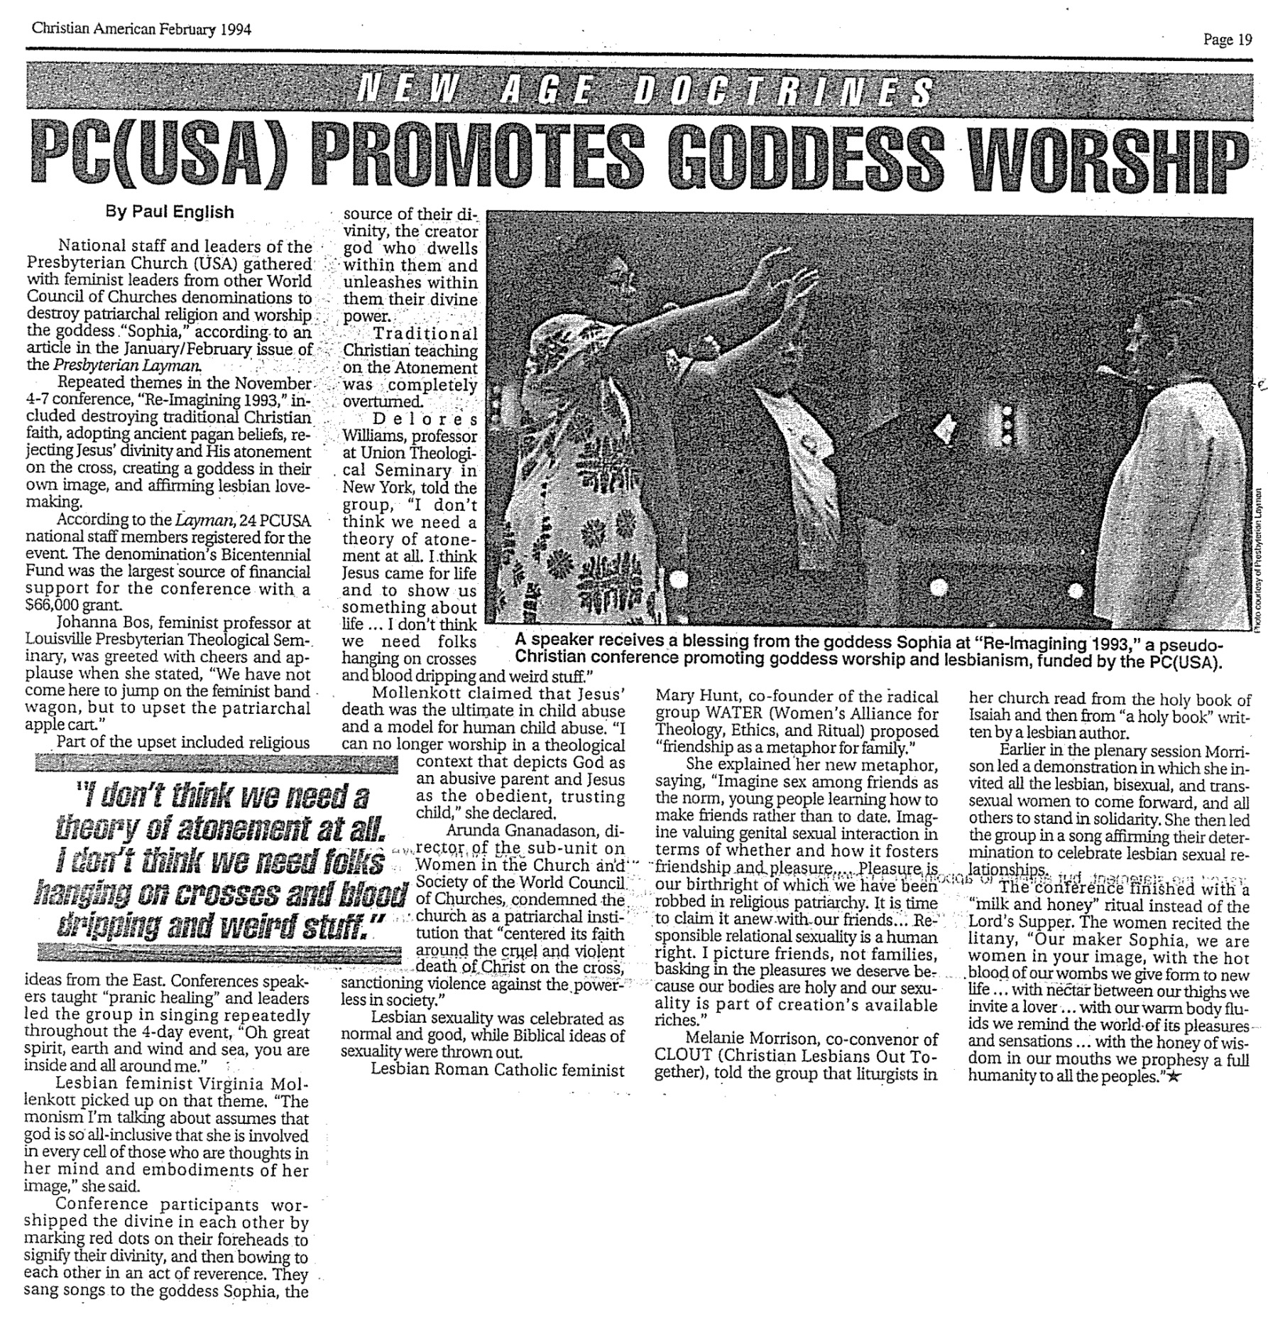

2 Peter Quoted in Jude

Much correlation exists between 2 Peter 2 and Jude. They are so similar that 2 Peter 2, penned before Peter’s death in AD 64, must have been summarized by Jude (AD 75). I have underlined the statements common to both passages in the parallel columns below.

2 Peter 2 (AD 64) | Jude (AD 75)
NIV 2 Peter 2:1 But there were also false prophets among the people, just as there will be false teachers among you. They will secretly introduce destructive heresies, even denying the sovereign Lord who bought them-- bringing swift destruction on themselves. ²Many will follow their shameful ways and will bring the way of truth into disrepute. ³In their greed these teachers will exploit you with stories they have made up. Their condemnation has long been hanging over them, and their destruction has not been sleeping. ⁴For if God did not spare angels when they sinned, but sent them to hell, putting them into gloomy dungeons to be held for judgment; ⁵if he did not spare the ancient world when he brought the flood on its ungodly people, but protected Noah, a preacher of righteousness, and seven others; ⁶if he condemned the cities of Sodom and Gomorrah by burning them to ashes, and made them an example of what is going to happen to the ungodly; ⁷and if he rescued Lot, a righteous man, who was distressed by the filthy lives of lawless men ⁸(for that righteous man, living among them day after day, was tormented in his righteous soul by the lawless deeds he saw and heard)-- ⁹if this is so, then the Lord knows how to rescue godly men from trials and to hold the unrighteous for the day of judgment, while continuing their punishment. ¹⁰This is especially true of those who follow the corrupt desire of the sinful nature and despise authority. Bold and arrogant, these men are not afraid to slander celestial beings; ¹¹yet even angels, although they are stronger and more powerful, do not bring slanderous accusations against such beings in the presence of the Lord.  ¹²But these men blaspheme in matters they do not understand. They are like brute beasts, creatures of instinct, born only to be caught and destroyed, and like beasts they too will perish. ¹³They will be paid back with harm for the harm they have done. Their idea of pleasure is to carouse in broad daylight. They are blots and blemishes, reveling in their pleasures while they feast with you. ¹⁴With eyes full of adultery, they never stop sinning; they seduce the unstable; they are experts in greed-- an accursed brood! ¹⁵They have left the straight way and wandered off to follow the way of Balaam son of Beor, who loved the wages of wickedness. ¹⁶But he was rebuked for his wrongdoing by a donkey-- a beast without speech-- who spoke with a man's voice and restrained the prophet's madness. ¹⁷These men are springs without water and mists driven by a storm. Blackest darkness is reserved for them. ¹⁸For they mouth empty, boastful words and, by appealing to the lustful desires of sinful human nature, they entice people who are just escaping from those who live in error. ¹⁹They promise them freedom, while they themselves are slaves of depravity-- for a man is a slave to whatever has mastered him. ²⁰If they have escaped the corruption of the world by knowing our Lord and Savior Jesus Christ and are again entangled in it and overcome, they are worse off at the end than they were at the beginning. ²¹It would have been better for them not to have known the way of righteousness, than to have known it and then to turn their backs on the sacred command that was passed on to them. ²²Of them the proverbs are true: "A dog returns to its vomit," and, "A sow that is washed goes back to her wallowing in the mud." | NIV Jude ⁴For certain men whose condemnation was written about long ago have secretly slipped in among you. They are godless men, who change the grace of our God into a license for immorality and deny Jesus Christ our only Sovereign and Lord.  ⁵Though you already know all this, I want to remind you that the Lord delivered his people out of Egypt, but later destroyed those who did not believe.  ⁶And the angels who did not keep their positions of authority but abandoned their own home-- these he has kept in darkness, bound with everlasting chains for judgment on the great Day.  ⁷In a similar way, Sodom and Gomorrah and the surrounding towns gave themselves up to sexual immorality and perversion. They serve as an example of those who suffer the punishment of eternal fire.  ⁸In the very same way, these dreamers pollute their own bodies, reject authority and slander celestial beings.  ⁹But even the archangel Michael, when he was disputing with the devil about the body of Moses, did not dare to bring a slanderous accusation against him, but said, "The Lord rebuke you!"  ¹⁰Yet these men speak abusively against whatever they do not understand;  and what things they do understand by instinct, like unreasoning animals-- these are the very things that destroy them. ¹¹Woe to them! They have taken the way of Cain; they have rushed for profit into Balaam's error; they have been destroyed in Korah's rebellion. ¹²These men are blemishes at your love feasts, eating with you without the slightest qualm-- shepherds who feed only themselves.  They are clouds without rain, blown along by the wind;  autumn trees, without fruit and uprooted-- twice dead.  ¹³They are wild waves of the sea, foaming up their shame; wandering stars, for whom blackest darkness has been reserved forever. ¹⁴Enoch, the seventh from Adam, prophesied about these men: "See, the Lord is coming with thousands upon thousands of his holy ones ¹⁵to judge everyone, and to convict all the ungodly of all the ungodly acts they have done in the ungodly way, and of all the harsh words ungodly sinners have spoken against him." ¹⁶These men are grumblers and faultfinders; they follow their own evil desires; they boast about themselves and flatter others for their own advantage. ¹⁷But, dear friends, remember what the apostles of our Lord Jesus Christ foretold. ¹⁸They said to you, "In the last times there will be scoffers who will follow their own ungodly desires." ¹⁹These are the men who divide you, who follow mere natural instincts and do not have the Spirit.

Jeremiah of Jerusalem

What if Jesus needed our modern marketing methods to get his way? The fictional “Jeremiah of Jerusalem” can help us see what it might be like if our Lord followed the ways of the world…

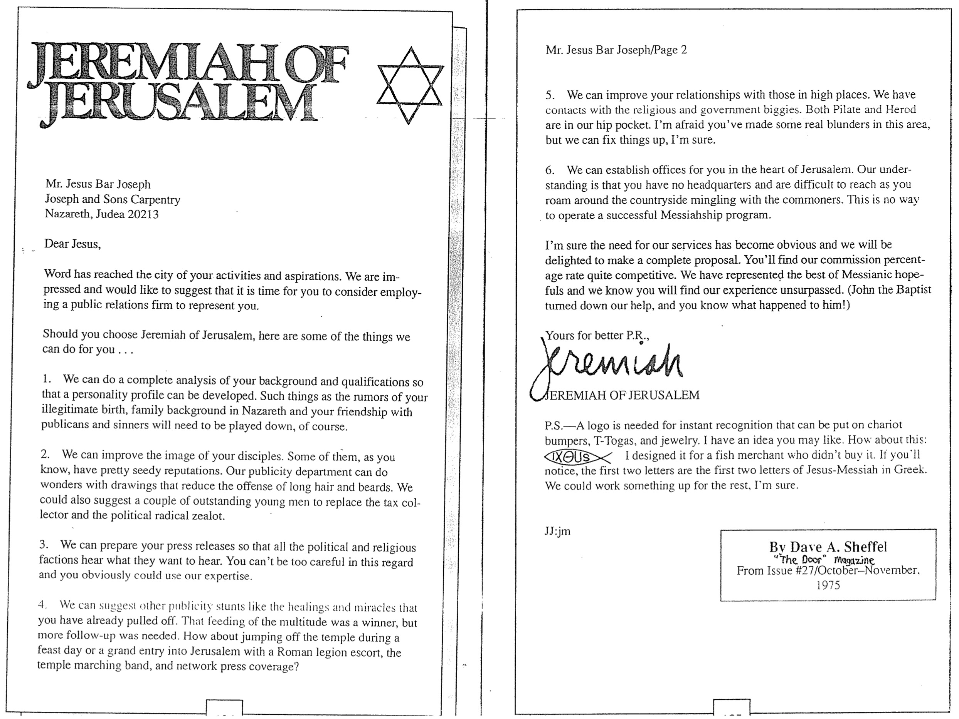

What is the Gospel?
(1 of 2)

Recently an evening school student wrote to ask why it took Christ’s blood to pay for our sin. With all the false gospels around today, his question reminded me of Jude’s exhortation for Christians “to contend for the faith” (v. 3). Yet how can we contend for something we don’t even understand? So below is my reply to his sincere and vital question (slightly edited).

What a great question you asked. I agree that too few of us stop long enough to evaluate why Christ had to die for us. We must accept it as a fact to be saved, but I think it shows maturity on your part to ask the “why” question. I'll try to answer your question in as simple words as possible.

Part of the answer relates to the balance in God between His love on one side and His perfection and fairness on the other.

Here's the problem...

God is perfect. This means He cannot stand sin. And the result for us is we cannot enter His presence with our sin. And because He is fair He must judge sin (require a penalty) so we all owe a debt to Him for our sin.

What is the penalty that God requires? Our sin doesn't just separate us from a perfect God a little, so the penalty God requires for our sin is death (Rom. 6:23). This is what the Bible means when it says that His fairness can only be satisfied with the shedding of blood (death is what we all deserve).

Capital crimes deserve capital punishment. Most of the time people don't think of themselves as having committed a capital crime like murder, but we all have. We look at ourselves in comparison to one another—and we generally compare ourselves to the worst people! This way we don't look so bad.

That works fine on a human plane when we are only trying to legislate society to the degree that everyone doesn't kill each other. But when we're talking about an issue of going to heaven and being with a holy God forever we must compare ourselves to this holy God! And He says that every one of us doesn’t measure up (Rom. 3:23).

When we see things this way we finally realize that we are in an awful predicament. We really are in bad shape–even the best of us!

Here's the solution...

There's good news though! God also loves us, so how can He show His love and yet not compromise His fairness? He in His love provides a way for His fair demands to be met with a substitute for us. God allows a substitute to take the penalty we deserve (Rom. 5:8).

Can a substitute really take our place? If I killed someone, would the government allow someone else to die by hanging instead of me? I can't answer this for Singapore law. Perhaps no one has ever volunteered before! But in some societies the demands of the law do not require that the one who takes the penalty be the one who committed the crime. In such cases a substitute is allowed.

So “without the shedding of blood there is no forgiveness” (Heb. 9:22). This has always been true. In OT times the blood spilled was the blood of a lamb. The worshipper placed his hand on the head of the animal and he killed it himself. Read Leviticus 1 and you'll see that it wasn't the priest who did the actual killing. This was a graphic way to show the worshipper that sin has a price.

Of course, we now know that an OT lamb ultimately pointed to Jesus as the final sacrifice for sin. This is why Revelation 4 calls Jesus the “Lamb” with a capital “L.”

What is the Gospel?
(2 of 2)

How was Jesus the ultimate sacrifice? For one, He was greater than man (lambs are lower in God's eyes than people, the crown of His creation). He was God and man simultaneously so He could bear the sin of man perfectly to satisfy the justice (fairness) of God.

Another difference is that lambs actually never sinned. There is something innocent about little, cute lambs–perhaps because they have not been tainted by sin. Only humans can sin since only humans have a conscience and an ability to choose between right and wrong. And every human has failed–all have sinned.

But Jesus was the only person that was fully human and yet without sin. He's the only one who ever passed the sin test–being tried and found innocent in every respect. Had Christ committed even one sin, He would have had to die for that sin. This would have disqualified Him from bearing our sin.

But praise God, Jesus never did commit His first sin. This allowed Him, if He died, to die for those that were under the penalty of sin. So He chose to die for us, satisfying our debt to God's fairness and simultaneously demonstrating God's love.

Isn't that the most wonderful news you have ever heard? It was to me! Now God says that for Christ's blood to apply to us we simply accept this by faith.

Why can't Christ's blood apply to everyone–even to those without faith? If He died for the whole world, why then isn't the whole world saved from the penalty of death? In OT times, the person had to express his faith to God. This was done through offering a lamb at the temple. In like manner, today faith must be expressed for forgiveness to come.

But how is faith expressed? The New Testament doesn't prescribe only one way to express faith. Typically people express faith in Christ through prayer, but the NT never actually gives us a specific prayer to use. Nevertheless, I think that prayer is probably the best way to show God that we want Christ's blood to apply to us.

What should that prayer include? Tell God you trust (believe) that Christ died for you and you want His forgiveness. This is called accepting Him as Saviour (substitute for your sin). Included in this is what the NT calls “repentance,” which literally means a “change of mind” concerning what you are trusting to save you from the penalty of sin. Don't trust your good works, church attendance, baptism, or anything else since none of these takes care of your basic problem: sin.

Sounds simple, right? Many think it's too simple–and they reject it for being too easy. In reality it is not hard at all, unless it is hard to humble yourself to the point of admitting that you can do absolutely nothing to save yourself! Notice that all these false ways people use to try to reach God (some listed above) are accomplished by us–and that can lead to pride. This is why Ephesians 2:8-9 says, “For by grace you have been saved through faith, and that is not of yourselves. It is the gift of God, not as a result of works, so that no one can boast.” There's no such thing as a proud person in heaven.

So, are you sure you have accepted the real gospel explained above? Have you expressed your trust in Christ in this manner before? If not, may I urge you to do it even today? Be sure to let me know about it.

Your friend in Christ,

Rick

PS: You may have noticed that most verses cited above are from the Book of Romans. Since this is the best full-length explanation of the gospel in the NT, I recommend you study it. The best short explanation of how the gospel is Christ’s death and resurrection for us is 1 Corinthians 15:1-11.

